User Manual

Hermit Crab

Hermit Crub members

Moreno Sardella, master degree student in computer science and engineering

Luca Fochetta, master degree student in computer science and engineering

Lorenzo Vignati, master degree student in biomedical science and engineering

Paolo Ritter, master degree student in biomedical science and engineering

Dimitar Anastasovski, master degree student in computer science and engineering

Summary

1 – General Information 3

1.1 – Overview 3

1.2 – Package’s Component 3

2 – Hermit Crab Installation 4

2.1 – Required Workspace 4

2.2 – Custom Menu and Hermit Crabs Installation 4

2.3 – Treasure Box 4

2.4 – Shell Installation 4

2.5 – Usage 4

2.6 – Enjoy 4

3 – Components Replacement 5

3.1 – Battery Replacement 5

3.2 – Soap Replacement 5

# 1 – General Information

## – Overview

Hermit Crab is a product composed of three robots used in a restaurant to attract people. There will be two small Hermit Crabs that will move on a custom menu and a Treasure Box that will be placed close to the menu.

When there is no one in front of the restaurant the Hermit Crabs will run inside the custom menu, meanwhile the Treasure Box will periodically trigger a Bubble Gun.

Instead, when there is someone approaching the restaurant the Treasure Box will perceive them and will do the following operations:

* Communicate with the Hermit Crabs and advise them that someone is approaching.
* Invite the people to go inside the restaurant.

The Hermit Crabs instead will do the following operations when someone is approaching:

* They will become afraid.
* They will run to the border of the menu.
* They will close their eyes and their shells.
* After few seconds they will move on the border of the menu.

## 1.2 – Package’s Component

On this manual will be explained how to properly use yours Hermit Crab. The package is composed of:

* 2 Hermit Crabs
* 2 Shells
* 2 Batteries
* 1 Treasure Box
* 1 Custom Menu
* 1 Battery Charger
* 1 Micro-usb cable
* 1 Power supplier

# 2 – Hermit Crab Installation

## 2.1 – Required Workspace

To properly use the Hermit Crab product, you will need a table that is at least 1x1 m.

## 2.2 – Custom Menu and Hermit Crabs Installation

The custom menu must be on the table unfolded, with the white part on top. The Hermit Crabs must be put on the white part of the menu.

## 2.3 – Treasure Box

The Treasure Box must be put next to the menu (on the left side), with the front side directed to the area where the people will walk. The Box must be closed to a power point to supply it. Then connect the plug.

## 2.4 – Shell Installation

The shell must be put on top of the Hermit Crab “cage” with the bigger part on the front of the hermit (see the image). Then you must delicately push the shell down until it will be fixed with the cage.

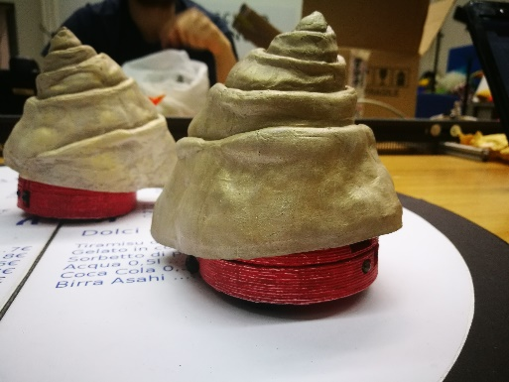

## 2.5 – Usage

To make the Hermit Crab work, you must turn them on by moving the switch placed on the bottom of them to On. Then you to press the button of the Treasure Box placed on the back of it to On.

## 2.6 – Enjoy

Now you have successfully installed yours Hermit Crab Product. Well Done!

# 3 – Components Replacement

## 3.1 – Battery Removal / Replacement

To replace the battery of a Hermit Crab you have to possess a battery LP-E8(7.4 V).

To Replace/charge the battery, you must follow these steps:

1. Gently remove the shell from the Hermit Crab.
2. Open up the cage.
3. Remove the wood connector from the battery.
4. Remove the battery and charge it or replace the old battery with the new one.
5. Reconnect the wood connector being very careful to the polarity.
6. Move the hermit crab arm in position (Figure 3.1.1) and move down the cage.
7. Gently put the shell on the cage (FOLLOW 2.4 – Shell Installation).

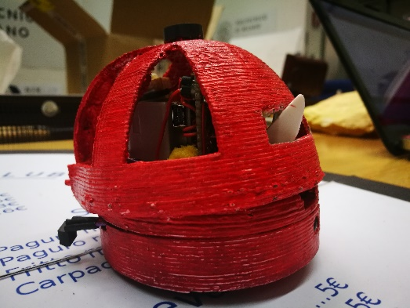

*Figure 3.1.1*

## 3.2 – Soap Replacement

To replace the soap on the Treasure Box you have to follow these steps:

1. Lift up the coin’s holder(SEE FIGURE 3.2.1).
2. Slip off the white wire (SEE FIGURE 3.2.2).
3. Pull up the Bubble Gun and slip it off from the trigger (SEE FIGURE 3.2.3).
4. Screw off the tank from the Bubble Gun, fullfill it and screw it on.
5. Put the Trigger in the correct position (SEE FIGURE 3.2.4) and put the Bubble Gun on its housing.
6. Slip on the white wire putting it on the small hole on the trigger (SEE FIGURE 3.2.5).
7. Pulll down the coin’s holder.

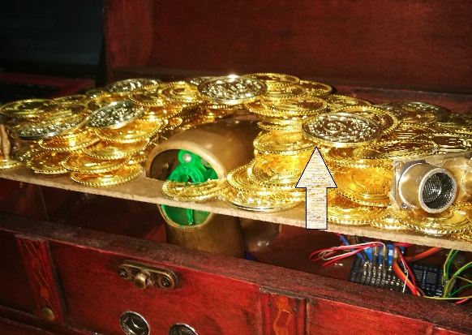 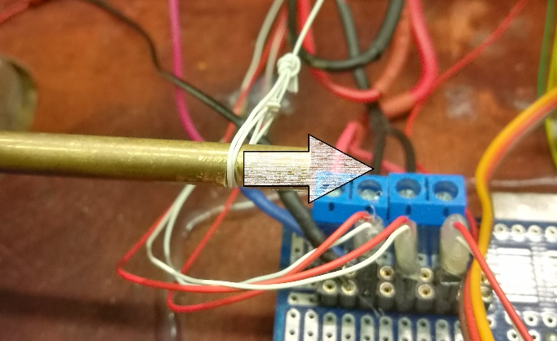

***Figure 3.2.1. Figure 3.2.2.***

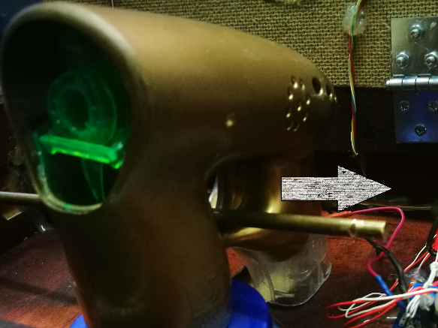 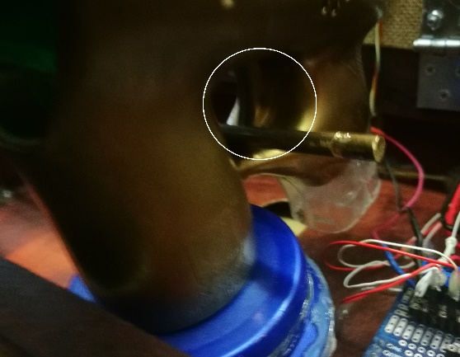

***Figure 3.2.3. Figure 3.2.4.***

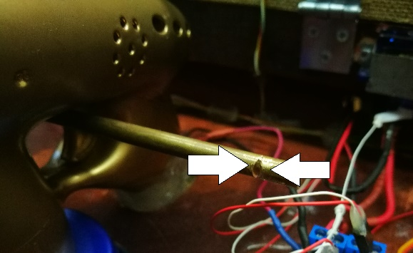

***Figure 3.2.5.***